

CITY OF BISMARCK

TITLE VI PLAN

August 2025

Title VI Coordinator
Leanne Schmidt, Director of Human Resources
221 N 5th Street, PO Box 5503, Bismarck, ND 58506-5503
Table of Contents
I. EQUAL EMPLOYMENT OPPORTUNITY ACT (EEO) 1
A. Equal Employment Opportunity (EEO) Report 1
B. Organization, Staffing, and Responsibilities 1
C. Purposes and Responsibilities 2
D. Selection Process 3
E. EEOC Reporting for Publicly Held Meetings 3
II. AMERICANS WITH DISABILITIES ACT (ADA) 4
A. Title VI Coordinator 4
B. ADA Coordinator 5
C. DBE Liaison Officer 6
D. City of Bismarck Title VI/Nondiscrimination and ADA Policy Statement 6
III. LIMITED ENGLISH PROFICIENCY PLAN 8
A. Introduction 8
B. Plan Summary 8
C. Meaningful Access: Four-Factor Analysis 9
D. Language Assistance 13
E. Language Assistance Measures 15
F. Staff Training 15
G. Monitoring 15
H. Dissemination of the City of Bismarck LEP Plan 16
IV. TITLE VI COMPLAINTS 16
A. Title VI/ADA Complaint Procedure 16
B. TITLE VI YEARLY REPORTING PRACTICE 20
V. TITLE VI PROGRAM MONITORING 20
VI. GOALS AND ACCOMPLISHMENTS 21
VII. APPENDIX A-1
A. Standard Title VI/Non-Discrimination Assurance and Appendices A-1
B. Airport Specific Provisions A-10
C. Propio Language Services Information A-20
D. Title VI/ADA Complaint Form A-23
E. Title VI Complaint Log A-27
F. Title VI Recipient Checklist A-28
G. Title VI Subrecipient Monitoring Checklist Form A-33

EQUAL EMPLOYMENT OPPORTUNITY ACT (EEO)

Equal Employment Opportunity (EEO) Report
The City of Bismarck is an equal opportunity employer and has employment policies that adhere to the Civil Rights Act of 1964 and the Americans with Disabilities Act (ADA).
Bi-annually, the City of Bismarck submits an EEO-4 Report on the demographics of its workforce. This is a required report for employers of 15 or more employees.
There is also EEO information submitted voluntarily by applicants of all posted positions. That information goes with the applicant if they become an employee.
The City of Bismarck is an equal opportunity employer and does not discriminate against or exclude any particular class of people based on race, color, religion, sex, national origin, age, disability, or genetic information. Vacancies are advertised on the City of Bismarck website, which is accessible to both internal and external candidates.

Organization, Staffing, and Responsibilities
The City of Bismarck operates under the commission form of municipal government; four commissioners and a mayor are elected at large and reside within the city limits. The City of Bismarck does not recognize wards or districts from which electors must reside. The Mayor serves as the President of the Board of City Commission. The President (Mayor) votes as a member of the board and does not have veto power.
There are five portfolios designated to each member of the City Commission. Each commissioner is responsible for serving as the liaison with the city department directors and committees, councils, or boards assigned. They prioritize their focus and communications to support operations. Every two years, after each election, a reorganization meeting is scheduled to distribute the portfolios to each commissioner.
Additionally, the city commission is advised by a number of boards and committees. The purpose and responsibilities of each are listed below.
Positions on the City of Bismarck's commissions, councils, boards, and committees are elected or appointed and are listed below. The organization members will be polled annually and given an opportunity to self-attest to their race and gender.
The City of Bismarck Administration Department ensures that notices for public meetings reach all segments of the impacted community. The Title VI Coordinator will identify the effective media platforms to share announcements and notices. Announcements are made in social media, general circulation newspapers, community newspapers, email broadcasts, and posted at the City/County Building public area.

Purposes and Responsibilities
Bismarck Parking Authority
Parking Authorities are allowed under state law. The Bismarck Parking Authority provides convenient, reasonably priced parking to the residents, clients, customers, merchants, and employees of the Downtown Parking District. The Parking Authority currently manages three ramps and one surface lot. The Bismarck City Commission appoints members and must be residents of the City of Bismarck, as well as other requirements for ownership in the affected area. http://www.bismarckparkingauthority.com/
City Commission
The Board of City Commissioners has the sole authority to pass and adopt rules and regulations concerning the organization, management, and operation of all the departments of the city and the other agencies created by it for the administration of the city's affairs. Reference: NDCC Sec. 40-09-14
Historic Preservation Commission
The Historic Preservation Commission is a seven-member board that carries out matters related to the Historic Preservation Ordinance of the City of Bismarck. Their duties include advising on matters related to nominations to the National Register of Historic Places, working to promote and educate about the City's history, heritage, historic properties, and past citizens, and serving as a local historic resource for the citizens and other City Boards/Commissions seeking historic expertise. https://bismarcknd.gov/1870/HIstoric-Preservation-Commission
Library Board
The Library Board of Directors governs library operations. Board members must be residents of Bismarck and are appointed by the City Commission under the authority of state statute to three-year terms. Meeting dates are subject to change by action of the Board. http://www.bismarcklibrary.org/159/Library-Board
Metropolitan Planning Organization (MPO) Policy Board
The Bismarck-Mandan MPO consists of the cities of Bismarck, Mandan, Lincoln, and portions of Burleigh and Morton Counties. The Policy Board represents the member cities/counties and is the decision-making body of the MPO. https://www.bismarcknd.gov/133/Metropolitan-Planning-Organization

Selection Process
The City of Bismarck follows a process for appointing individuals to the various advisory boards within local government. When a position becomes vacant, the City Administration Department works collectively with other City departments to advertise the vacancy and announce the application for appointment. The local newspaper, the Bismarck Tribune, is provided with a press release containing information pertinent to the vacant position. The announcement is also posted on the City's social media accounts and the City's official website- bismarcknd.gov. In most cases, residency in the city is a requirement for serving as a board or committee member. The exception would be the City Planning and Zoning Commission, which provides two positions for individuals who live within the City's Extra Territorial Area (ETA); these representatives reside within Burleigh County but outside the corporate limits of the City of Bismarck.
The City of Bismarck provides a unified advisory board application to any member of the public who is interested in applying for an open position on a board. The applications are collected by the department director whose department staffs the advisory Board. The department director reviews each application to determine qualifications and credentials appropriate for serving in an advisory capacity. A recommendation from the department director is provided to the Board of City Commissioners, at which time the Commission is tasked with confirming the recommendation or passing on the application(s) at a regularly scheduled meeting, which occurs on the second and fourth Tuesday of each month.

EEOC Reporting for Publicly Held Meetings
The Civil Rights Act of 1964 and related nondiscrimination authorities require the North Dakota Department of Transportation to ensure everyone has the opportunity to comment on the transportation programs and activities that may affect their community.
The City of Bismarck monitors attendance to ensure equal opportunity at all publicly held meetings. The public participation survey found at the NDDOT’s website https://www.dot.nd.gov/forms/sfn60149.pdf is be presented for voluntary participation of the attendees. This survey is for affirmative action purposes only. It will aid in monitoring attendance, determining demographics being reached, and how to announce future meetings to the public.

AMERICANS WITH DISABILITIES ACT (ADA)

Title VI Coordinator
The Title VI Coordinator is charged with the responsibility for implementing, monitoring, and ensuring the City's compliance with Title VI regulations. Title VI responsibilities are as follows:
  - Proactively ensures that the City is in compliance with nondiscrimination requirements of Title VI and reports to City of Bismarck leadership on the status of Title VI compliances.
  - Responds promptly to requests by Federal Authorities for data and records and for the scheduling of compliance reviews and other meetings to determine compliance with Title VI and related requirements.
  - Process the disposition of Title VI complaints received by the City and forward them to the applicable Federal Authorities within 15 days of receipt, together with any actions taken to resolve the matter.
  - Provides applicable Federal Authority with updates regarding its response and status of early resolution efforts to complaints concerning Title VI and related requirements (49 CFR Part 21, Appendix C(b)(3)), including resolution efforts.
  - Coordinates data collection to evaluate whether racial or ethnic groups are unequally benefited or impacted by City programs. The data will be regularly assessed and readily available upon request (49 CFR § 21.9(b) & (c)). Data collection methods may include but are not limited to optional demographic questions in City customer satisfaction surveys, customer complaints, City event sign-in sheets, bids/proposals for City contracts, and other methods.
  - Maintains demographic data for members of appointed planning and advisory bodies for the Airport and identifies any disparities compared to the community. Provides information to the membership selecting official/committee, particularly when vacancies occur.
  - Collect statistical data (race, color, sex, age, disability, or national origin) of participants in and beneficiaries of state highway programs, e.g., relocates, affected citizens, and impacted communities.
  - Conduct Title VI reviews of construction contractors, consultant contractors, suppliers, and other recipients of federal-aid highway fund contracts administered through the City.
  - Annually reviews City Title VI Plan program directives and, where applicable, includes Title VI language and related requirements. Disseminate information throughout the staff and City leadership.
  - Conduct training programs on Title VI and other related statutes, including anti-harassment training, language, and assistance resources and practices, collecting and assessing demographic data, reporting Title VI complaints and other required program-specific notifications for City employees and, which include the following: Include a statement about the City of Bismarck's Title VI Plan in the Employee Newsletter, advise all employees of the availability of the Title VI Plan on the City of Bismarck's Intranet, post the Title VI Plan on the City of Bismarck Internet, post the Title VI Plan on employee bulletin boards at City of Bismarck worksites, inform all employees that a copy of the Title VI Plan is available upon request and instruct all new employees about the Title VI Plan during orientation. See appendix for department-specific sponsor responsibilities.
  - Prepare a yearly report of Title VI accomplishments and goals, as required.
  - Develop Title VI information for dissemination to the general public and, where appropriate, in languages other than English, and post the Title VI Plan on the City of Bismarck web page.
  - Conduct post-grant approval reviews of City programs and applicants (e.g., highway location, design and relocation, and persons seeking contracts with the City) for compliance with Title VI requirements.
  - Identify and take corrective action to help eliminate discrimination.
  - Establish procedures to promptly resolve identified Title VI deficiencies. Document remedial actions agreed to be necessary. Provide remedial actions within 90 days of identification of a deficiency.
  - Establish, maintain, and coordinate a Limited English Proficiency Plan as detailed within this document.
  - Ensure federally sponsored programs have and maintain a Community Participation Plan (CPP).
  - Maintains a copy of 49 CFR Part 21 for inspection by any person asking for it during normal working hours (49 CFR 21, Appendix C (b)(2)(i)).

ADA Coordinator
The Americans with Disabilities Act (ADA) of 1990 is a companion civil rights legislation with the Civil Rights Act of 1964 and Section 504 of the Rehabilitation Act of 1973, which prohibits discrimination against people with disabilities. ADA implementing regulations to Title II of the act prohibit discrimination in the provision of services, programs, and activities by state and local governments such that "…No qualified individual with a disability shall, on the basis of disability, be excluded from participation in or be denied the benefits of the services, programs, or activities of a public entity, or be subjected to discrimination by any public entity." 28 CFR § 35.130(a).
The City of Bismarck will make every reasonable accommodation to provide an accessible meeting facility for all persons and ensure that communications with applicants, participants, and members of the public with disabilities are as effective as communications with others, 28 CRF §35.160. Individuals may request appropriate provisions, auxiliary aids, or services (such as sign language, interpreter, accessible parking, or materials in alternative format) by contacting the ADA Coordinator, Director of Human Resources, City of Bismarck, at 701-355-1330 or TDD 711, or at hr@bismarcknd.gov.
The Americans with Disabilities Act requires public agencies with more than 50 employees to create and maintain a transition plan. The City of Bismarck employs more than 50 employees; for information about the City of Bismarck's ADA transition plan, please contact Human Resources Department. Contact information is listed above.
As the Americans with Disabilities Act is companion civil rights legislation with the Civil Rights Act of 1964, all disability/handicap-related complaints will follow the complaint procedures and forms as outlined in the City of Bismarck Title VI and Nondiscrimination Program.
Complaints about violations of ADA by units of state and local governments may also be filed directly with the US Department of Justice. For assistance, please call the toll-free ADA Information Line at 800-514-0301 (voice) or 800-514-0383 (TYY) or go to http://www.ada.gov/.

DBE Liaison Officer
The DBE Liaison Officer shall have direct, independent access to the Mayor as the Chief Executive Officer for the City of Bismarck concerning DBE program matters. The liaison officer is responsible for implementing all aspects of your DBE program. You must also have adequate staff to administer the program in compliance with this part.

City of Bismarck Title VI/Nondiscrimination and ADA Policy Statement
The City of Bismarck prohibits discrimination on the basis of race, color, national origin (including limited English proficiency (LEP)), sex (including sexual orientation and gender identity), creed, or age, as provided by Title VI of the Civil Rights Act of 1964, the Civil Rights Restoration Act of 1987 (PL 100.259), Section 520 of the Airport and Airway Improvement Act of 1982 (if applicable), Section 162(a) of the Federal-Aid Highway Act of 1973 of 23 USC 324 (if applicable), Age Discrimination Act of 1975g, and Section 504 of the Rehabilitation Act of 1973/ADA of 1990 and related authorities (hereafter, "Title VI and related requirements"). Title VI and the additional Nondiscrimination requirements are applicable to programs receiving federal financial assistance due to the Civil Rights Restoration Act of 1987.
There are two Presidential Executive Orders that place further emphasis on the Title VI protections of race and national origin. Executive Order 12898 ensures nondiscrimination against minority populations by discouraging programs, policies, and activities with disproportionately high and adverse human health or environmental effects on minority and low-income populations. Executive Order 13166 directs recipients of Federal financial assistance that to ensure compliance with Title VI; they must take reasonable steps to ensure that limited English proficiency persons have meaningful access to their programs.
The City of Bismarck is personally committed to and supports taking all steps to ensure that no person or groups of persons shall, on the grounds of race, color, national origin, sex, age, disability, limited English proficiency, or income status, be excluded from participation in, be denied the benefits of, or be otherwise subjected to discrimination under any and all programs, services, or activities administered by The City of Bismarck, its recipients, sub-recipients, and contractors. Additionally, the City of Bismarck agrees, among other things, to understand the communities surrounding or in the flight path of its Airport, as well as customers that use the Airport. Anytime communities may be impacted by programs or activities, the City of Bismarck takes action to involve them and the general public in the decision-making process.
The City of Bismarck Human Resources Director is appointed as the Title VI Coordinator and ADA Coordinator and is granted the authority to develop, administer, and monitor the Title VI/Nondiscrimination and ADA Program as promulgated. The City of Bismarck requires nondiscrimination assurances from each tenant, contractor, and concessionaire providing an activity, service, or facility at any federally funded location in the City of Bismarck, including the Airport and other entities. Assurances must be included in any related lease, contract, or franchise agreement between the City of Bismarck and each tenant, contractor, and concessionaire, as well as in any similar agreements with their sub-tenants and sub-contractors.
Anyone who needs additional information or believes that he or she has been discriminated against should contact Human Resources Title VI Coordinator and ADA Coordinator, PO Box 5530, Bismarck, ND 58506, hr@bismarcknd.gov or 701-355-1330. TTY users may call Relay North Dakota at 711 or 1 800-366-6888 (toll-free).

LIMITED ENGLISH PROFICIENCY PLAN

Introduction
This Limited English Proficiency Plan (LEP) has been prepared to address the City of Bismarck's responsibilities as a sub-recipient of federal financial assistance as they relate to the needs of individuals with Limited English Proficiency language skills. The plan has been prepared in accordance with Title VI of the Civil Rights Act of 1964, 42 USC 2000d, et seq, and its implementing regulations, which state that no person shall be subjected to discrimination on the basis of race, color, or national origin.
Executive Order 13166, titled Improving Access to Services for Persons with Limited English Proficiency, indicates that differing treatment based upon a person's inability to speak, read, write, or understand English is a type of national origin discrimination. It directs each agency to publish guidance for its respective recipients, clarifying their obligation to ensure that such discrimination does not take place. This order applies to all state and local agencies that receive federal funds, including all the City of Bismarck and its sub-recipients.

Plan Summary
The City of Bismarck has developed this Limited English Proficiency Plan to help identify reasonable steps for providing language assistance to individuals with Limited English Proficiency (LEP) who wish to access the services provided. As defined in Executive Order 13166, LEP individuals are those who do not speak English as their primary language and have limited ability to read, speak, write, or understand English. This plan outlines how to identify a person who may need language assistance, the ways in which assistance may be provided, staff training that may be required, and how to notify LEP individuals that assistance is available.
In order to prepare this plan, the City of Bismarck used the four-factor LEP analysis, which considers the following factors:
- The number or proportion of LEP persons served or encountered in the City of Bismarck.
- The frequency with which LEP individuals come in contact with the program, activity, or services.
- The nature and importance of the program, activity, or service provided by the program.
- The resources available to the Recipient and costs.

Meaningful Access: Four-Factor Analysis
- The Number or proportion of LEPs served or encountered in the eligible service population.
The City of Bismarck is a local public agency with a defined service area as follows: areas within the boundaries of the city of Bismarck. Services may be provided by a specific area as follows: police, fire, administration, public works, library, and municipal court. The City of Bismarck's defined service area does not include the public school district or the park district.
All previous contacts with LEP persons were identified by language along with the type of service provided for the reporting period, January 1, 2022, through December 31, 2022. The following contacts occurred.
In-person contacts: In-person contacts are not specifically identified separately from the interpretive services in the last period.
Telephonic Interpreter Services:
Telephonic Interpreter Services (January 2022 - December 2022)
Department | French | Spanish | Arabic | Vietnamese | Burmese | Swahili | Chuukese | Turkish | Russian
Central Communications | 2 | 66 | 2 |  |  |  |  | 1 | 1
Public Health | 8 | 11 |  | 1 | 6 | 2 | 1 |  | 1
Municipal Court |  | 86
Police Department |  | 11 |  | 1 |  | 1 | 2
Attorney |  | 1
Event Center |  | 1
Grand Total | 9 | 90 | 2 | 2 | 6 | 3 | 3 | 2 | 2
The City of Bismarck attempted to identify LEP minority populations that are eligible beneficiaries who may be underserved because of existing language barriers.
Additional data on LEP populations was obtained from sources such as census, school systems, religious organizations, community organizations, community agencies, and state and local governments.
The City of Bismarck consulted additional data sources:
US Census for the City of Bismarck
- 2017-2021 American Community Survey 5-Year Estimates

  - The City of Bismarck staff reviewed the 2017-2021 American Community Survey 5-Year Estimates for the City of Bismarck and determined that 3,170 individuals in the city of Bismarck (4.6 % of the population) speak a language other than English. Of those, 1,059 individuals have limited English proficiency; that is, they speak English less than "very well" or "not at all." This is only 1.5 % of the overall population in the City of Bismarck.
  - Individuals with Limited English Proficiency that are greater in number than 5% of the language group are:
Language | Total | Total who speak English Less than very well | Percent
Spanish | 888 | 395 | 44%
German or West Germanic languages | 698 | 75 | 11%
Other Unspecified languages | 318 | 106 | 33%
Russian, Polish, or other Slavic languages | 285 | 127 | 45%
French, Haitian, or Cajun | 257 | 135 | 52%
Other Indo-European languages | 282 | 29 | 10%
Tagalog, (incl. Filipino) | 223 | 75 | 34%
Arabic | 88 | 65 | 74%
Vietnamese | 66 | 9 | 14%
Chinese (Incl. Mandarin, Cantonese) | 28 | 28 | 100%
Other Asian and Pacific Island languages | 27 | 15 | 55%
Data from 2021: ACS 5-year Estimates Table B16001
- Characteristics of People by Language Spoken at Home – Table S1603, 2017-2021 ACS 5 Year Estimates report language estimates. Around 4% of all children, ages 5 to 17, speak a language other than English at home. For adults ages 18 and over, that number is 5%.
North Dakota Department of Public Instruction (NDDPI) - Reports the English Language Learner languages.
- In 2021-2022, NDDPI reported 3,534 ELL students in 12 school districts across ND. Bismarck Public School District has 388 ELL students, or about 9% of the ELL student population.
ND Department of Health & Services (NDDHHS) is administering the state refugee resettlement program. The Lutheran Social Services of North Dakota (LSSND) previously provided refugee resettlement in ND through January 2021.
- NDHHS is the state agency responsible for managing the resettlement of refugee programs in North Dakota.
Fiscal Year | Settled in Bismarck, ND
2018 | 22
2019 | 24
2020 | 8
2021 | 1
2022 | 54
- The frequency with which LEP individuals encounter the program, activity, or service.
The City of Bismarck identified the frequency with which City of Bismarck staff have or should have contact with LEP individuals from different language groups seeking assistance. Spanish-speaking individuals are the most frequently encountered LEP language group.
Telephonic Interpreter Services (January to December 2022)
Department | French | Spanish | Arabic | Vietnamese | Burmese | Swahili | Chuukese | Turkish | Russian
Central Communications | 2 | 52 | 2 |  |  |  |  | 1 | 1
Public Health | 6 | 9 |  | 1 | 6 | 1
Municipal Court |  | 8
Police Department |  | 8 |  | 1 |  | 1 | 3 |  | 1
Attorney |  | 1
Civic Center |  | 1 |  |  |  |  |  | 1
Grand Total | 8 | 79 | 2 | 2 | 6 | 2 | 3 | 2 | 2
- Telephonic interpreter service was used for all 98 walk-in and/or call-in customers during the past 12-month reporting period of January 2022 through December 2022.
- Contacts ranged from 1 per month to 22 per month for an average of 9 calls per month.

- The nature and importance of services provided by the City of Bismarck to the LEP population.
The City of Bismarck determined the importance of its services for the LEP population in its service area by reviewing and considering the following factors, including the identification of vital documents.
Identification of Vital Documents
A document will be considered vital if it contains information that is critical for obtaining federal services and/or benefits or is required by law.
- Examples:
  - Applications
  - Consent and complaint forms
  - Notices of rights and disciplinary action
  - Notices advising LEP persons of the availability of free language assistance
    - Written tests that assess competency for a particular license, job, or skill for which English competency is not required
    - Letters or notices that require a response from the beneficiary or client
  - In larger documents, the translation of vital information contained within the document will suffice and need not be translated in its entirety.
  - Outreach docs: It is difficult to determine if a vital lack of awareness may effectively deny LEP persons access. It's important to continually survey/assess the needs of eligible service populations to determine what outreach materials are critical to translate.
The City of Bismarck provides a Request for Reasonable Accommodations form for individuals to request services for oral or written translations as determined by the Four-Factor Analysis or defined by Safe Harbor requirements. Safe Harbor applies to written translations only.
Vital documents will be translated when a significant number of percentages of the population eligible to be served or likely to be directly affected by the program/activity need services or information in a language other than English to communicate effectively. The Title VI complaint form and ADA policy statement are identified as vital documents.
If the English language version is posted on the City of Bismarck website, the translation will be posted on the website.
The City of Bismarck considered the importance of immediate and long-term effects of a delay in written translations. Most services have several days to weeks allowed for comment or completion.
Failure to provide written translation under these cited circumstances does not mean that the City of Bismarck is in noncompliance; rather, it provides a starting point for the City of Bismarck to consider in relation to the Four Factors.
- The resources available to the Recipient and costs.
The city contracted with Telelanguage in April 2018 with Telelanguage Services. In 2022, Telelanguage was acquired by Propio Language Services, who honored the contract started with the city. Interpretation rates are listed below and paid by the city.
- Phone interpretation services rate is $1.05 per minute.
- Written translation services rate is $0.19 per word with 250 words minimum.
Oral telephonic and written interpreter services are provided free of charge for the people served.

Language Assistance
A person who does not speak English as their primary language or who has a limited ability to read, write, speak, or understand English may be a Limited English Proficient person and may be entitled to language assistance with respect to City of Bismarck services.
Language assistance can include interpretation, which means an oral or spoken transfer of a message from one language into another language, and/or translation, which means the written transfer of a message from one language into another language.
After applying the four-factor analysis, the City of Bismarck has examined the following language assistance options and identified which methods will provide the City of Bismarck with an effective LEP Plan. Spanish-speaking individuals are most frequently encountered by the City of Bismarck.

Language Assistance Services

Oral Language Services

Using Propio Language Services interpreter lines offers prompt interpreting assistance in many different languages. Services are available 24 hours a day, 365 days a year by calling 800-514-9237, then providing a first name and a department access code. See Appendix G for more information.
- Contracting for Interpreters
  - The North Dakota Courts have an interpreters list available for independent contractors.
- Use of family members, friends, and other customers/passengers as interpreters
  - The City of Bismarck allows, at the request of LEP individuals, if they are not willing to speak with an interpreter provided by the City of Bismarck.
Written Language Services - Translation of Documents
For 'vital' City of Bismarck documents, if there are fewer than 50 persons in a language group (that reaches five percent of the population of persons eligible to be served or likely to be affected or encountered), the City of Bismarck does not translate 'vital' written materials but will provide written notice in the primary language of the LEP language group of the right to receive competent oral interpretation of those written materials, free of cost.
- Identification of Vital Documents
  - A document will be considered vital if it contains information that is critical for obtaining federal services and/or benefits or is required by law.
    - Examples:
      - Applications
      - Consent and complaint forms
      - Notices of rights and disciplinary action
      - Notices advising LEP persons of the availability of free language assistance
      - Written tests that assess competency for a particular license, job, or skill for which English competency is not required
      - Letters or notices that require a response from the beneficiary or client
      - For larger documents, the translation of vital information contained within the document will suffice and need not be translated in its entirety.
      - Outreach docs: difficult to determine if vital- lack of awareness may effectively deny LEP persons access. It's important to continually survey/assess the needs of eligible service populations to determine what outreach materials are critical to translate.
Failure to provide written translation under these cited circumstances does not mean that the sub-recipient is in noncompliance; rather, it provides a starting point for sub-recipients to consider in relation to the Four Factors.

Language Assistance Measures
The City of Bismarck employees will inform all LEP individuals attempting to access services that the City of Bismarck provides free interpreter services upon request for their interactions with the City of Bismarck.
When the City of Bismarck receives a request or identifies a need for services, the City of Bismarck will make every effort to provide the services in a timely manner. The City of Bismarck will pay for interpreter services and translation of vital documents as necessary.

Staff Training
Training includes how to obtain language assistance services and communication with interpreters and translators.
- Annual training is provided to all City of Bismarck employees.
  - Information to know their obligations to provide meaningful access to information and services for LEP persons.
  - Information on City of Bismarck LEP procedures
  - Description of language assistance services offered to the public.
  - Instructions to work effectively with telephone interpreters.
  - Instructions for transferring calls with LEP individuals on the telephone line.
  - Use Propio Language Services telephonic interpreter language lists and resource materials. Use of "I Speak" cards for in-person LEP individuals. It is located at: http://www.justice.gov/sites/default/files/crt/legacy/2010/12/14/ISpeakCards.pdf

Monitoring
The City of Bismarck will update the LEP Plan as required. The plan has been updated with data from the 2020 US Census and is available when higher concentrations of LEP individuals are present in the City of Bismarck service area. Updates will include the following:
- The number of encountered LEP persons, by language, who received language assistance services annually.
- The frequency of encounters with LEP persons
- The current/primary language of LEP populations in the service area.
- Whether the need for translation services has changed.
- Whether local language assistance programs have been effective.
- Whether the City of Bismarck's financial resources are sufficient to fund language assistance resources needed.
- Determine whether the City of Bismarck fully complies with the goals of this LEP Plan.
- Determine the number and type of complaints received concerning the needs of LEP individuals.
- Whether staff are knowledgeable about City of Bismarck LEP procedures.

Dissemination of the City of Bismarck LEP Plan
- Post the City of Bismarck LEP Plan to their website.
- Post City of Bismarck LEP Plan in all City Buildings and employee breakrooms.
- Display free language assistance posters in all the City of Bismarck building's public areas.
- State on agendas, public notices, brochures, flyers, and ads that a Request for Reasonable Accommodation is available to request language assistance (oral interpretation and written translation) of documents from the City of Bismarck.

TITLE VI COMPLAINTS

Title VI/ADA Complaint Procedure
This procedure outlines the Title VI and ADA complaint procedures related to providing programs, services, and benefits. It does not deny the Complainant the right to file formal complaints with the applicable state or federal agency or to seek private counsel for complaints alleging discrimination, intimidation, or retaliation of any kind that is prohibited by law.
Title VI of the Civil Rights Act of 1964 and Titles II and III of the Americans with Disabilities Act of 1990 requires that no person in the United States shall, on the grounds of disability, race, color, or national origin, be excluded from, be denied the benefits of, or be subjected to discrimination under any program or activity receiving federal financial assistance.
Any person who believes that they have been subjected to discrimination may file a written complaint with the City of Bismarck. Complaints must be filed within 180 calendar days of the alleged incident.
The Complainant may download the complaint form from the CITY OF BISMARCK website (https://www.bismarcknd.gov/1413/Title-VI) or request the complaint form from the Title VI Coordinator.
The complaint will include the following information:
- Name, address, telephone number and email address of the Complainant.
- The cause of discrimination, i.e., race, color, national origin, sex, age, disability or limited English proficiency.
- The name of the public entity complaint is against.
- The explanation of what happened and dates and location of the alleged discriminatory act.
- Complainant's signature and date.
- If the Complainant is unable to write a complaint, City of Bismarck staff will assist the Complainant.
- The complaint may be mailed to the following address: City of Bismarck, 221 N. Fifth St, Bismarck, ND 58501.
- The complaint may be sent via email to lschmidt@bismarcknd.gov. The Complainant also has the right within the 180-day timeframe to file a Title VI or ADA claim with the appropriate agency:
North Dakota Department of Transportation  Civil Rights Division  608 E Boulevard Ave.  Bismarck, ND 58507-0700  Phone: (701) 328-2576  TTY: 711 or (800) 366-6888  Email: civilrights@nd.gov | United States Department of Transportation  (USDOT) Departmental Office of Civil Rights  US Department of Transportation  Office of Civil Rights  1200 New Jersey Ave., SE.  Washington, DC 20590  Phone: (202) 366-4648  Fax: (202) 366-5575  TTY/Assistive Device: (202) 366-9696
FHWA  North Dakota Division Office  4503 Coleman St. N., Suite 205  Bismarck, ND 58503  Phone: (701) 250-4204  Fax: (701) 250-4395  Email: NorthDakota.fhwa@dot.gov | USDOJ - Race, Color, National Origin Complaints  Federal Coordination and Compliance Section - NWB  Civil Rights Division  US Department of Justice (USDOJ)  950 Pennsylvania Avenue, NW.  Washington, DC 20530  Phone: (888) 848-5306 (English and Spanish)  (202) 307-2222 (voice)  (202) 307-2678 (TDD)

United States Department of Transportation (FHWA)  Federal Highway Administration  US Department of Transportation  Office of Civil Rights  1200 New Jersey Ave., SE.  8th Floor E81-105  Washington, DC 20590  Phone: (202) 366-0693  Fax: (202) 366-1599  TTY: (202) 366-5132  Email: CivilRights.FHWA@dot.gov | USDOJ - ADA Complaints  US Department of Justice (USDOJ)  950 Pennsylvania Avenue, NW.  Civil Rights Division  Disability Rights Section –  1425 NYAV Washington, DC 20530  Fax: (202) 307-1197  ADA Information Line:  (800) 514-0301 (voice) or (800)514-0383 (TTY) Main Section Telephone Number:  (202) 307-0663 (voice and TTY)
Federal Transit Administration (FTA)  Office of Civil Rights  Attention: Complaint Team  East Building, 5th Floor - TCR  1200 New Jersey Ave., SE.  Washington, DC 20590  Phone: (888) 446-4511 | Federal Aviation Administration  Office of Civil Rights  (ACR-4)  800 Independence Avenue SW  Washington DC, 20591  (718)553-3297  Complaint link: https://www.faa.gov/about/office_org/headquarters_offices/acr/external-discrimination-complaints/form

Internal Complaint Referral. All Title VI complaints received by departments must be promptly forwarded to the coordinator within five business days of receipt.
The City of Bismarck will begin an investigation and will contact the Complainant in writing no later than fifteen (15) working days after receipt of the Title VI complaint or five (5) days after receipt of the ADA complaint. The Complainant will be notified within 30 days if additional information is required to investigate the complaint. If the Complainant fails to provide the requested information on a timely basis, the City of Bismarck may administratively close the complaint.
The City of Bismarck will use its best effort to complete the investigation of Title VI and ADA complaints within sixty (60) calendar days of receipt of the complaint. A written investigation report will be prepared by the investigator and sent to the Complainant filing the complaint. The report shall include a summary description of the incident, findings, and recommendations for disposition.
Consultation with Legal Counsel. In each case, the coordinator will consult with the Legal Counsel regarding the investigation and the report. Legal counsel will ensure that the report is consistent with the applicable Title VI nondiscrimination requirements.
Forwarding Report and Response to Complainant. At the completion of the investigation, the Complainant and respondent will receive a letter of findings and determination of the investigation and any applicable resolution. The letter transmitting the findings and any applicable resolution will state City's conclusion regarding whether unlawful discrimination occurred and will describe the Complainant's appeal rights.
Intimidation and Retaliation Prohibited. City of Bismarck employees, contractors, and tenants will not intimidate or retaliate against a person who has filed a complaint alleging discrimination.
Appeal Rights. The Complainant must be notified of their right to appeal the findings or determinations and of the procedures and requirements for an appeal:
- The Complainant may appeal in writing to the Bismarck City Administrator
- The written appeal must be received within ten (10) business days after mailing of the written decision.
- The written appeal must contain all arguments, evidence, and documents supporting the basis for the appeal.
- The Bismarck City Administrator will issue a final written decision in response to the appeal.
This complaint procedure is shared with the public through the following methods:
- Websites, In-person, and Other Distribution Methods
Bismarck Airport Additional Procedures
Initial FAA Notification. A copy of each Title VI complaint will be forwarded to the FAA within 15 days of initial receipt (not the date that the coordinator was notified). The airport staff supporting the coordinator will forward a copy of the complaint and a statement describing all actions taken to resolve the matter and the results thereof to the FAA Civil Rights staff. (Note: complaints based on disability do not have to be forwarded to FAA.) To transmit complaint information to the FAA, the Coordinator will upload information to the FAA Civil Rights Connect System, which issues automated notifications to FAA staff. The coordinator will also seek technical assistance from the FAA, as needed, throughout the complaint intake, investigation, and resolution process.
Cooperation with FAA. The coordinator will promptly investigate all Title VI complaints, including those referred by the FAA for investigation. If the FAA is investigating a complaint against the City of Bismarck, the Coordinator will avoid interfering with the FAA investigation, cooperate with the FAA when needed, and share factual information with the FAA.
A summary of the investigation report, any appeal, or follow-up actions will be sent to the FAA via the FAA Civil Rights Connect System.

TITLE VI YEARLY REPORTING PRACTICE
At the end of each fiscal year, the City of Bismarck will have a yearly complaint reporting log. This will list all Title VI complaints that have come in during that time frame.
The City of Bismarck will identify and implement measures to reduce the chances of similar discrimination in the future.

TITLE VI PROGRAM MONITORING
Title VI program monitoring exists at both the recipient and subrecipient level. Each City department that receives federal funds has staff participation in an internal Title VI workgroup. Annually at a minimum, the workgroup convenes to review the Title VI plan and any areas of concern. Each department is required to monitor Title VI requirements specific to each funding agency. No program areas are outside of compliance at this time.
The Title VI Recipient Checklist/Form and the Title VI Subrecipient Monitoring Checklist/ Form will be completed on an annual basis and provided to appropriate federal agencies requiring them at appropriate times. The Forms are a Word document and provide additional detail to accompany the checklist, which is saved in Excel. The suggested review period is in January to cover activities of the prior year (January-December). A representative from the City of Bismarck Human Resources Department and/or an assigned City personnel will complete the Title VI Recipient Checklist to ensure the City's Title VI procedures and plan follow federal regulations. The DBE Liaison Officer will follow up with the city personnel to ensure the City's checklist is completed. The DBE Liaison Officer will also complete the Title VI Subrecipient Monitoring Checklist to ensure that the City's Title VI processes and plan are being carried out. At a minimum, both checklists will be collected and saved by the DBE Liaison Officer for review annually. If requested by a federal agency, the checklists may also be uploaded to TrAMS or sent directly to the Title VI Oversight Agent at FTA Region 8 or another location. The following pages provide the questions and framework for the checklists as mentioned above.
Additional Information/Actions Requested of Sub-Recipient of the FTA Only:
- Listing of Title VI complaints/lawsuits that have occurred since the latest Title VI program Submission.
- List of transit facilities sited since the last Comprehensive Review and a copy of corresponding equity analyses.
- List of transit facilities to be constructed/leased in the upcoming three Federal fiscal years and a copy of equity analysis completed or scheduled for equity analysis completion.
- List of any fare increases or major service changes since the latest Title VI program submission, the date of the change, and a brief description of the change.
- Any service equity and/or fare equity analyses conducted since the submission of the last Title VI program for fare or major service changes.
- Any service equity and/or fare equity analyses conducted since the submission of the last Title VI program for new fixed guideway service, New Starts, or Small Starts projects.
- Competitive selection or annual program of projects process.
- List of all sub-recipient applications received during the review period and identify those:
  - Accepted or Rejected
  - Applicants that are minority organizations or that serve minority or low-income communities
  - Amount of funds allocated
- Are there any other known issues that should be addressed within the Subrecipients Title VI Plan?

GOALS AND ACCOMPLISHMENTS
Goals: The City of Bismarck has cited these as the goals to reach.
  - Provide a good response to the City of Bismarck's Title VI plan during any potential audit.
  - Transition responsibilities of Title VI coordination to an HR Generalist who will continue to work with the Title VI Coordinator.
  - Collaborate with the commissions, councils, boards, and committees to provide information by explaining the forms and their purpose to encourage participation.
  - Prepare and present for all-staff training during the year.
  - Continue to update the City of Bismarck's Title VI plan.
  - Continue to update the City of Bismarck's ADA plan.
  - Gather updated census information as available.
  - Monitor the NDDOT Title VI website for any required form updates and make changes to posted documents as needed.
Accomplishments: During the triennial period, here are the accomplishments obtained by the City of Bismarck in compliance with the Title VI program.
- The completed thorough review and update of the City of Bismarck Title VI Plan.
- The City of Bismarck employees reviewed annual training material on Title VI and Limited English Proficiency.
- The City of Bismarck's Title VI program coordination continues to be with the MPO's Title VI program to assist each other with questions and ideas and help to ensure each program flourishes.
- Ensured continued interpretive services with the change to Propio Language Services and provided updated information to departments and employees.
Training:
New employee orientation incorporates Title VI training. Topics include:
- Title VI and related laws prohibit discrimination on the basis of race, color, national origin (including LEP), sex (including sexual orientation and gender identity), creed, or age.
- Title VI complaints must be forwarded to the Coordinator.
- Protections against retaliation for filing civil rights complaints or related actions.
- Title VI notices must be displayed throughout the Airport's public facilities.
- All contracts must include Title VI clauses.
- Language interpretation and translation services.
- Cultural and community relations sensitivity training.
- Anti-harassment training.

Refresher information will be provided annually.

APPENDIX
City of Bismarck

Standard Title VI/Non-Discrimination Assurance and Appendices
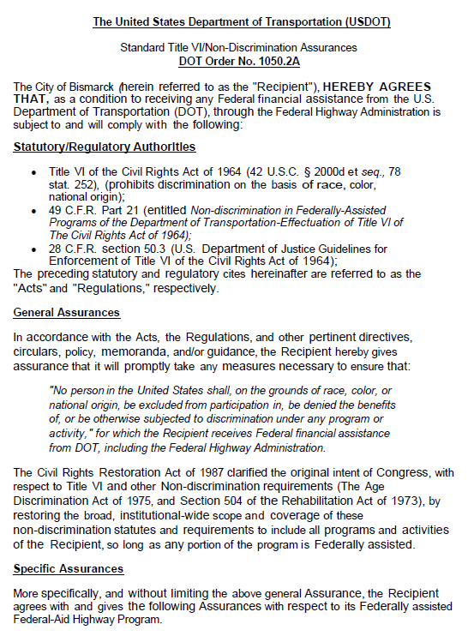
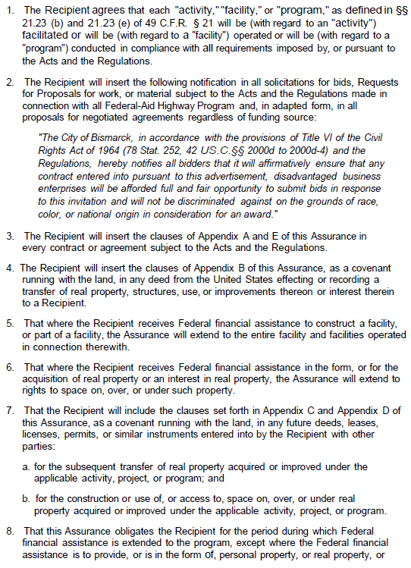
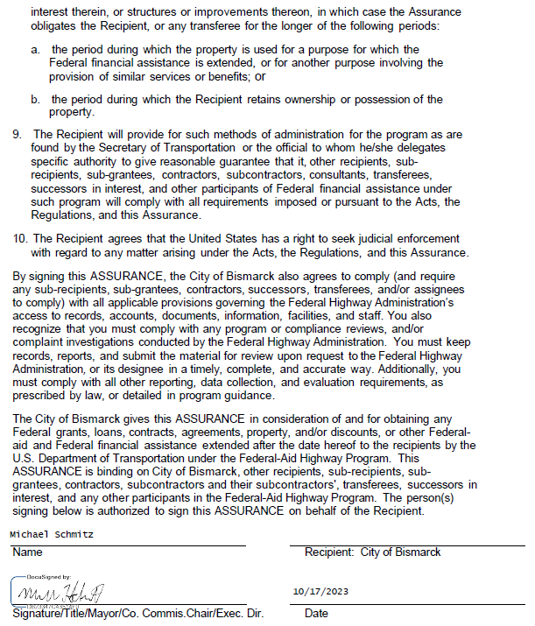

Appendix A of Title VI Assurances
During the performance of this contract, the Contractor, for itself, its assignees, and successors in interest (hereinafter referred to as the Contractor) agrees as follows:
- Compliance with Regulations: The Contractor (hereinafter includes consultants) will comply with the Acts and the Regulations relative to Nondiscrimination in Federally assisted programs of the US Department of Transportation, the Federal Highway Administration, the Federal Aviation Administration, as they may be amended from time to time, which are herein incorporated by reference and made a part of this contract. The link to FAA contract provisions is found at https://www.faa.gov/airports/aip/grant_assurances/#current-assurances.

- Nondiscrimination: The Contractor, with regard to the work performed by it during the contract, will not discriminate on the grounds of race, color, or national origin in the selection and retention of subcontractors, including procurements of materials and leases of equipment. The Contractor will not participate directly or indirectly in the discrimination prohibited by the Acts and the Regulations, including employment practices, when the contract covers any activity, project, or program set forth in Appendix B of 49 CFR Part 21.

- Solicitations for Subcontracts, Including Procurements of Materials and Equipment: In all solicitations, either by competitive bidding or negotiation made by the Contractor for work to be performed under a subcontract, including procurements of materials or leases of equipment, the Contractor will notify each potential subcontractor or supplier of the Contractor's obligations under this contract and the Acts and the Regulations relative to Nondiscrimination on the grounds of race, color, or national origin.

- Information and Reports: The Contractor will provide all information and reports required by the Acts, the Regulations, and directives issued pursuant thereto and will permit access to its books, records, accounts, other sources of information, and its facilities as may be determined by the Recipient or the Federal Highway Administration to be pertinent to ascertain compliance with such Acts, Regulations, and instructions. Where any information required of a Contractor is in the exclusive possession of another who fails or refuses to furnish the information, the Contractor will so certify to the Recipient or the Federal Highway Administration as appropriate and will set forth what efforts it has made to obtain the information.

- Sanctions for Noncompliance: In the event of a contractor's noncompliance with the nondiscrimination provisions of this contract, the Recipient will impose such contract sanctions as it or the Federal Highway Administration may determine to be appropriate, including, but not limited to:
  - withholding payments to the Contractor under the contract until the Contractor complies and/or
  - canceling, terminating, or suspending a contract, in whole or in part.

- Incorporation of Provisions: The Contractor will include the provisions of paragraphs one through six in every subcontract, including procurements of materials and leases of equipment, unless exempt by the Acts, the Regulations, and directives issued pursuant thereto. The Contractor will act with respect to any subcontract or procurement as the Recipient or the Federal Highway Administration may direct as a means of enforcing such provisions, including sanctions for noncompliance. Provided that if the Contractor becomes involved in or is threatened with litigation by a subcontractor or supplier because of such direction, the Contractor may request the Recipient to enter into any litigation to protect the interests of the Recipient. In addition, the Contractor may request the United States to enter into litigation to protect the interests of the United States.

Appendix B of the Title VI Assurances
CLAUSES FOR DEEDS TRANSFERRING UNITED STATES PROPERTY
The following clauses will be included in deeds effecting or recording the transfer of real property, structures, or improvements thereon, or granting interest therein from the United States pursuant to the provisions of Assurance 4:
NOW, THEREFORE, the US Department of Transportation as authorized by law and upon the condition that the City of Bismarck will accept title to the lands and maintain the project constructed thereon in accordance with Title 23, United States Code, the Regulations for the Administration of the Federal-Aid Highway Program, and the policies and procedures prescribed by the Federal Highway Administration of the US Department of Transportation in accordance and in compliance with all requirements imposed by Title 49, Code of Federal Regulations, US Department of Transportation, Subtitle A, Office of the Secretary, Part 21, Nondiscrimination in Federally-assisted programs of the US Department of Transportation pertaining to and effectuating the provisions of Title VI of the Civil Rights Act of 1964 (78 Stat. 252; 42 USC § 2000d to 2000d-4), does hereby remise, release, quitclaim and convey unto the City of Bismarck all the right, title and interest of the US Department of Transportation in and to said lands described in Exhibit A attached hereto and made a part hereof.
(HABENDUM CLAUSE)
TO HAVE AND TO HOLD said lands and interests therein unto the City of Bismarck and its successors forever, subject, however, to the covenants, conditions, restrictions, and reservations herein contained as follows, which will remain in effect for the period during which the real property or structures are used for a purpose for which Federal financial assistance is extended or for another purpose involving the provision of similar services or benefits and will be binding on the City of Bismarck, its successors and assigns.
The City of Bismarck, in consideration of the conveyance of said lands and interests in lands, does hereby covenant and agree as a covenant running with the land for itself, its successors and assigns, that (1) no person will on the grounds of race, color, or national origin, be excluded from participation in, be denied the benefits of, or be otherwise subjected to discrimination with regard to any facility located wholly or in part on, over, or under such lands hereby conveyed [,] [and]* (2) that the City of Bismarck will use the lands and interests in lands and interests in lands so conveyed, in compliance with all requirements imposed by or pursuant to Title 49, Code of Federal Regulations, US Department of Transportation, Subtitle A, Office of the Secretary, Part 21, Non­ discrimination in Federally-assisted programs of the US Department of Transportation, Effectuation of Title VI of the Civil Rights Act of 1964, and as said Regulations and Acts may be amended[, and (3) that in the event of breach of any of the above-mentioned nondiscrimination conditions, the Department will have a right to enter or re-enter said lands and facilities on said land, and that above described land and facilities will thereon revert to and vest in and become the absolute property of the US Department of Transportation and its assigns as such interest existed prior to this instruction].*
(*Reverter clause and related language to be used only when it is determined that such a clause is necessary in order to make clear the purpose of Title VI.)

Appendix C of the Title VI Assurances
CLAUSES FOR TRANSFER OF REAL PROPERTY ACQUIRED OR IMPROVED UNDER THE ACTIVITY, FACILITY, OR PROGRAM
The following clauses will be included in deeds, licenses, leases, permits, or similar instruments entered into by the City of Bismarck pursuant to the provisions of Assurance 7(a):
A. The (grantee, lessee, permittee, etc., as appropriate) for themselves, their heirs, personal representatives, successors in interest, and assigns, as a part of the consideration hereof, does hereby covenant and agree [in the case of deeds and leases add "as a covenant running with the land"] that:
1. In the event facilities are constructed, maintained, or otherwise operated on the property described in this (deed, license, lease, permit, etc.) for a purpose for which a US Department of Transportation activity, facility, or program is extended or for another purpose involving the provision of similar services or benefits, the (grantee, licensee, lessee, permittee, etc.) will maintain and operate such facilities and services in compliance with all requirements imposed by the Acts and Regulations (as may be amended) such that no person on the grounds of race, color, or national origin, will be excluded from participation in, denied the benefits of, or be otherwise subjected to discrimination in the use of said facilities.
B. With respect to licenses, leases, permits, etc., in the event of a breach of any of the above Nondiscrimination covenants, the City of Bismarck will have the right to terminate the (lease, license, permit, etc.) and to enter, re-enter, and repossess said lands and facilities thereon, and hold the same as if the (lease, license, permit, etc.) had never been made or issued. *
C. With respect to a deed, in the event of a breach of any of the above Nondiscrimination covenants, the City of Bismarck will have the right to enter or re-enter the lands and facilities thereon, and the above-described lands and facilities will thereupon revert to and vest in and become the absolute property of the City of Bismarck and its assigns. *
(*Reverter clause and related language to be used only when it is determined that such a clause is necessary to make clear the purpose of Title VI.)

Appendix D of the Title VI Assurances
CLAUSES FOR CONSTRUCTION/USE/ACCESS TO REAL PROPERTY ACQUIRED UNDER THE ACTIVITY, FACILITY OR PROGRAM
The following clauses will be included in deeds, licenses, permits, or similar instruments/agreements entered into by the City of Bismarck pursuant to the provisions of Assurance 7(b):
A. The (grantee, licensee, permittee, etc., as appropriate) for himself/herself, his/her heirs, personal representatives, successors in interest, and assigns, as a part of the consideration hereof, does hereby covenant and agree (in the case of deeds and leases add, "as a covenant running with the land") that (1) no person on the ground of race, color, or national origin, will be excluded from participation in, denied the benefits of, or be otherwise subjected to discrimination in the use of said facilities, (2) that in the construction of any improvements on, over, or under such land, and the furnishing of services thereon, no person on the ground of race, color, or national origin, will be excluded from participation in, denied the benefits of, or otherwise be subjected to discrimination, (3) that the (grantee, licensee, lessee, permittee, etc.) will use the premises in compliance with all other requirements imposed by or pursuant to the Acts and Regulations, as amended, set forth in this Assurance.
B. With respect to (licenses, leases, permits, etc.), in the event of breach of any of the above Non­ discrimination covenants, The City of Bismarck will have the right to terminate the (license, permit, etc., as appropriate) and to enter or re-enter and repossess said land and the facilities thereon, and hold the same as if said (license, permit, etc., as appropriate) had never been made or issued.*
C. With respect to deeds, in the event of a breach of any of the above Nondiscrimination covenants, the City of Bismarck will thereupon revert to and vest in and become the absolute property of the City of Bismarck and its assigns. *
(*Reverter clause and related language to be used only when it is determined that such a clause is necessary to make clear the purpose of Title VI.)

Appendix E of the Title VI Assurances

During the performance of this contract, the contractor, for itself, its assignees, and successors in interest (hereinafter referred to as the Contractor) agrees to comply with the following nondiscrimination statutes and authorities, including but not limited to:

Pertinent Nondiscrimination Authorities:
• Title VI of the Civil Rights Act of 1964 (42 USC § 2000d et seq., 78 stat. 252) (prohibits discrimination based on race, color, and national origin); and 49 CFR Part 21.
• The Uniform Relocation Assistance and Real Property Acquisition Policies Act of 1970 (42 USC § 4601), (prohibits unfair treatment of persons displaced or whose property has been acquired because of Federal or Federal-aid programs and projects);
• Federal-Aid Highway Act of 1973, (23 USC § 324 et seq.), (prohibits discrimination on the basis of sex);
• Section 504 of the Rehabilitation Act of 1973 (29 USC § 794 et seq.), as amended, (prohibits discrimination on the basis of disability); and 49 CFR Part 27;
• The Age Discrimination Act of 1975, as amended (42 USC § 6101 et seq.), (prohibits discrimination on the basis of age);
• Airport and Airway Improvement Act of 1982 (49 USC § 471, Section 47123), as amended, (prohibits discrimination based on race, creed, color, national origin, or sex);
• The Civil Rights Restoration Act of 1987 (PL 100-209), (Broadened the scope, coverage, and applicability of Title VI of the Civil Rights Act of 1964, The Age Discrimination Act of 1975, and Section 504 of the Rehabilitation Act of 1973, by expanding the definition of the terms "programs or activities" to include all of the programs or activities of the Federal-aid recipients, sub-recipients and contractors, whether such programs or activities are Federally funded or not);
• Titles II and III of the Americans with Disabilities Act, which prohibit discrimination on the basis of disability in the operation of public entities, public and private transportation systems, places of public accommodation, and certain testing entities (42 USC §§ 12131-12189) as implemented by Department of Transportation regulations at 49 CFR parts 37 and 38;
• The Federal Aviation Administration's Nondiscrimination statute (49 USC § 47123) (prohibits discrimination on the basis of race, color, national origin, and sex);
• Executive Order 12898, Federal Actions to Address Environmental Justice in Minority Populations and Low-Income Populations, which ensures nondiscrimination against minority populations by discouraging programs, policies, and activities with disproportionately high and adverse human health or environmental effects on minority and low-income populations;
• Executive Order 13166, Improving Access to Services for Persons with Limited English Proficiency, and resulting agency guidance, national origin discrimination includes discrimination because of limited English proficiency (LEP). To ensure compliance with Title VI, you must take reasonable steps to ensure that LEP persons have meaningful access to your programs (70 Fed. Reg. at 74087 to 74100);
• Title IX of the Education Amendments of 1972, as amended, which prohibits you from discriminating because of sex in education programs or activities (20 USC 1681 et seq).

Airport Specific Provisions
Title VI Policy Statement
City of Bismarck assures that no person shall on the grounds of race, color, national origin (including limited English proficiency (LEP)), sex (including sexual orientation and gender identity), creed, or age, as provided by Title VI of the Civil Rights Act of 1964, the Civil Rights Restoration Act of 1987 (PL 100.259), Section 520 of the Airport and Airway Improvement Act of 1982, and related authorities (hereafter, “Title VI and related requirements”), be excluded from participation in, be denied the benefits of, or be otherwise subjected to discrimination under any program or activity that receives U.S. Department of Transportation (DOT) funding. Title VI also prohibits retaliation for asserting or otherwise participating in claims of discrimination.
City of Bismarck further assures every effort will be made to ensure nondiscrimination in all its programs and activities, whether those programs are federally funded or not. The Airport Sponsor agrees, among other things, to understand the communities surrounding or in the flight path, as well as customers that use the airport. Anytime communities may be impacted by programs or activities the City of Bismarck will take action to involve them and the general public in the decision-making process.
City of Bismarck requires nondiscrimination assurances, as prescribed by FAA, from each tenant, contractor, and concessionaire providing an activity, service, or facility at the airport. Assurances must be included in any related lease, contract, or franchise agreement between City of Bismarck and each tenant, contractor, and concessionaire, as well as in any similar agreements with their own sub-tenants and sub-contractors.
Leanne Schmidt available at (701) 355-1330 and hr@bismarcknd.gov, is responsible for overseeing the Airport Sponsor’s compliance with Title VI and the point of contact for all airport Title VI matters and related responsibilities, including those required by 49 CFR Part 21.

Signature Effective Date
Leanne Schmidt
Director of Human Resources [Effective Date plus 3 years]
3-Year Expiration Date

In addition to the Coordinator and City's leadership, the following people also assist with our Title VI program requirements specifically for the city's Airport:
Staff Supporting Title VI Program | Airport Sponsor Program / Office
Assistant Airport Director | Bismarck Airport
The City has the following airport program sub-recipients:
Sub-Recipients
None
As of the date of this plan, the City has the following pending applications for Federal financial assistance for Airport projects:
Federal Source | Grant Number | Amount
FAA AIP Special Discretionary | TBD (Wetland Phase 9) | $8,100,000
In addition, the City's Airport's sub-recipients have the following pending applications for Federal financial assistance (either directly from the FAA or passed through the State DOT.
Federal Source | Grant Number | Amount
None
Updated information for pending and awarded grant applications will be available through the following methods:
Federal Source | Grant Award Information Available at:
FAA-Dakota Minnesota ADO | Kyle Sebesta, Kyle.E.Sebesta@faa.gov.
The Coordinator has not requested and received access to the Title VI portion of the FAA Civil Rights Connect System (https://faa.civilrightsconnect.com/); however, Airport staff supporting Title VI Program, Timothy Thorsen has received access to the Title VI portion of the Civil Rights Connect System.
The City of Bismarck will conspicuously display the FAA-provided Unlawful Discrimination Poster in all public areas on airport property, including those with pedestrian activity. The Coordinator ensures that these posters are visible, accessible, and maintained. The poster template is available at Unlawful Discrimination Poster (faa.gov), and a completed copy is attached. See Section 15 Appendix.
Posters are displayed in the terminal and other areas on City of Bismarck Airport property, including the following public locations:
Terminal/FBO/Concessions/  Other Locations | Quantity in  Pre-Security Area | Quantity in  Post-Security Area | Additional Quantities
All three Passenger Terminal Entrances and Information Center  Passenger Boarding Area | 4 | 2 | 0
Car Rental Counters | 3
FBO Lobbies |  |  | 2
Runway Express Lobby |  |  | 1
"Affected Communities" means any readily identifiable group potentially impacted by an airport project or operation, such as the community immediately surrounding a project or a community in the flight path. The City of Bismarck Administration Department contacts leaders and representatives in Affected Communities directly to confirm effective media platforms to reach all Affected Communities and provide important feedback on translated materials. The office maintains records of all such notices and the efforts made to reach each of the Affected Communities.
Detailed information on our public notice and outreach procedures is available in the Bismarck Airport Community Participation Plan ("CPP"). A copy of the CPP is available at https://www.bismarckairport.com/. A copy of each CPP report completed since the last Title VI Plan will be attached to the CPP.
To ensure that the community is effectively informed of and able to participate in public hearings, Bismarck Airport includes public notices translated into appropriate languages, including for any language spoken by a significant number or proportion of the Affected Community population that has limited English proficiency (LEP). Such social media postings and notices will include directions for obtaining an interpreter, free of charge, for public hearings. 28 CFR § 42.405(d). See Limited English Proficiency (LEP) Section. Vital written documents which include, but are not limited to, consent and complaint forms; intake and application forms with the potential for important consequences; written notices of rights; notices of denials, losses, or decreases in benefits or services; notice of disciplinary action; signs; and notices advising LEP individuals of free language assistance services are available in translated languages on our website.
6. Community Statistics
Title VI regulations require Federal grant recipients to know their community demographics. See 49 CFR § 21.9(b). By knowing this information, the City of Bismarck will be able to identify, understand, and engage with communities. In doing so, the City of Bismarck needs to know about communities eligible to be served, actually or potentially affected, benefited, or burdened by the City of Bismarck's airport program.
Affected Communities | Population
City of Bismarck | 76,625
(Hereafter, the above communities will be referred to collectively as "the Affected Communities").
We have identified the following facts about the Affected Communities:
Low-Income Communities
A low-income area is an identifiable group of persons living in geographic proximity whose median household income is at or below the Department of Health and Human Services poverty guidelines. Pursuant to Executive Order 12898, "Federal Actions to Address Environmental Justice in Minority Populations and Low-Income Populations," the City of Bismarck is collecting information about affected and potentially affected low-income communities. According to the US Census Bureau Poverty in the United States: 2021, Table B-5, number, and percentage of people in Poverty by State using 3 Year Average, the overall poverty level for the state of North Dakota is approximately 9.1 %. The poverty rate remains similar compared with the rest of the state of North Dakota.
Affected Communities | Poverty Rate
City of Bismarck | 9.1 %
Racial and Ethnic Communities
Demographic data for race, color, and national origin was evaluated to identify racial and ethnic communities and populations in each Affected Community. The demographic composition by race, color, or national origin for the specific Affected Communities are as follows:
Affected Community: City of Bismarck
Total Affected Community Population: 76,625
Demographic Group within Affected Community | Number of People in Minority Group | Percent of Total Affected Community Population
White | 68,732 | 89.7%
Black or African American | 2,068 | 2.7
American Indian or Alaska Native | 3,754 | 4.9%
Asian | 613 | 0.8%
Native Hawaiian or other Pacific Islander | 229 | 0.3%
Hispanic or Latino | 1,839 | 2.4%
More than one | 2,988 | 3.9%
White alone, not Hispanic or Latino | 65,667 | 85.7%
See Census Quick Facts, Bismarck City, North Dakota https:/www. Census.gov/quickfacts/bismarckcitynorthdakota. Note Burleigh County is not listed in the "Persistent Poverty" or "Tracts of Poverty" for North Dakota
Beneficiary Diversity
Demographic information is collected from airport customers, attendees at community meetings, and businesses seeking opportunities at the Airport through voluntary disclosures.
Description of Beneficiary Demographic Information Collection Methods
- Using a QR code placed throughout the Airport, Bismarck Airport conducts ongoing surveys of airport guests for a voluntary request for demographic information.
- Participants at pre-bid meetings and other public meetings are asked to complete an anonymous survey that includes demographic information.
- Businesses that submit bids or offers are asked to complete an anonymous survey that includes demographic information using a QR code placed in the specification document and submitted through a data collection website.

Potential or Known Community Impacts
Projects or services receiving federal financial assistance have the potential to touch so many aspects of American life. Thus, in general, no City of Bismarck activity must have a discriminatory disparate impact on the basis of race, color, national origin (including LEP), sex (including sexual orientation and gender identity), creed, or age. This means that policies or procedures that have a disparate impact would require a well-documented, substantial, legitimate, nondiscriminatory justification, summarized below. Impacts to protected communities must be avoided or minimized to the extent possible. No project with a discriminatory impact on protected communities will be undertaken.
The following airport facilities are already in use or under construction and are expected to be in use within the next three years.
Existing Airport Facilities | Affected Community Impacted by Operation of the Facility
Commercial Passenger Terminal Bldg. 17 | None
Terminal Public Parking lots | None
Snow Removal Building 18 | None
Runway 13-31 | None
Runway 03-21 | None
Taxiway B | None
Taxiway C | None
Taxiway D | None
Taxiway E | None
Passenger Terminal Apron | None
General Aviation Apron | None
ARFF Building 14 | None
Operations Building 15 | None
Hangar 5 | None
Hangar 41 | None
Airport Access/Service Road System | None
The following airport facility projects (including all alternatives) are in construction or expected to be in construction within the next three years:
Airport Facility Construction Projects | Affected Community Impacted by Construction of the Facility
Wetland Removal Phase 5/6 | None
Wetland Removal Phase 7/8 | None
Wetland Removal Phase 9 | None
SRE Building Project | None
GA Apron Phase 4 | None
Hangar 5 Demolition and GA Apron Phase 5 | None
Taxiway C North Rehabilitation | None
Runway 3-21 & Taxiway D Rehabilitation | None
Passenger Boarding Bridge #2 & #3 Replacement | None
Terminal Expansion Study | None
We have analyzed the above existing facilities and facility construction projects for disparate impacts on the basis of race, color, or national origin (including LEP) in Affected Communities. The following have disparate impacts:
Facilities or Construction Projects with Disparate Impacts | Affected Community Impacted | Impact Can Be Eliminated?
None
Justifications: None
Facilities or Construction Projects | Justification
None

Transportation
49 Part CFR 21 Appendix C (a)(1)(ix)
In the Community Statistics section of this plan, we identified Affected Communities and provided demographic and related data for the community populations. The minority and disadvantaged community areas located within the Affected Communities are identified below. Other minority and disadvantaged community areas that are near the Airport but not within Affected Communities are also identified below.
We have coordinated with Bis-Man Transit to encourage them to provide transit service access between the Airport and these areas.
The following chart identifies existing and planned transit services connecting the airport employment centers with the identified minority and disadvantaged community areas.
Minority and/or Disadvantaged Community Areas | Transit Service | Planned or Existing
Bismarck-Mandan Transit | Fixed-Route buses | Existing
Bismarck- Mandan Transit | Paratransit vans | Existing

10. Minority Businesses
49 CFR 21 Appendix C (a)(1)(x)
Bids for airport concessions and other business opportunities are solicited from area minority and woman-owned businesses through the following methods:
Airport Business Opportunity | Minority Business Outreach Methods
Café, Gift Shop, Bar | Advertised (Public Notice) through local newspaper of record, published on City and Airport Websites, advertised nationally in the American Association of Airport Executives website, and direct outreach to known ACDBEs on the NDDOT website (Unified Certification Program for ND).
Snack and Beverage Concession | Advertised (Public Notice) through local newspaper of record, published on City and Airport Websites, advertised nationally in the American Association of Airport Executives website, and direct outreach to known ACDBEs on the NDDOT website (Unified Certification Program for ND). Currently filled with qualified ACDBE.
Pay Parking Lot Management Contract | Advertised (Public Notice) through the local newspaper of record, published on City and Airport Websites, advertised nationally in the American Association of Airport Executives website, and direct outreach to known ACDBEs on the NDDOT website (Unified Certification Program for ND).
Airport Advertising | Advertised (Public Notice) through the local newspaper of record, published on City and Airport Websites, advertised nationally in the American Association of Airport Executives website, and direct outreach to known ACDBEs on the NDDOT website (Unified Certification Program for ND).
Selections comply with Title VI, Part 21, and related requirements. Information on the award process and documentation for specific bid decisions is kept with the Bismarck Airport administration.
Initial FAA Notification. A copy of each Title VI complaint will be forwarded to the FAA within 15 days of initial receipt (not the date that the Coordinator was notified). The Coordinator will forward a copy of the complaint and a statement describing all actions taken to resolve the matter and the results thereof to the FAA Civil Rights staff. (Note: complaints based on disability do not have to be forwarded to FAA.) To transmit complaint information to the FAA, the Coordinator will work with the Assistant Airport Director, who will upload the information to the FAA using the FAA Civil Rights Connect System, which issues automated notifications to FAA staff. The Coordinator, assisted by the Assistant Airport Director or designee, will also seek technical assistance from the FAA, as needed, throughout the complaint intake, investigation, and resolution process.
Forwarding Report and Response to Complainant. At the completion of the investigation, the Complainant and respondent will receive a letter of findings and determination of the investigation and any applicable resolution. The letter transmitting the findings and any applicable resolution will state the City of Bismarck's conclusion regarding whether unlawful discrimination occurred and will describe the Complainant's appeal rights. A summary of the investigation report, any appeal, or follow-up actions will be sent to the FAA via the FAA Civil Rights Connect System.
15. Completed Unlawful Discrimination Poster
Unlawful Discrimination Poster (faa.gov)
FAA Notification. The Coordinator will notify FAA of any pending investigations and reviews, including:
• Compliance reviews or audits concerning civil rights requirements
• Complaints, lawsuits, or other investigations alleging noncompliance with civil rights requirements
Title VI complaints must be forwarded to FAA contacts within 15 days of receipt. For all other civil rights investigations, the City of Bismarck must notify FAA contacts of any new investigations prior to grant execution.
At regular intervals, the Coordinator will provide FAA contacts with status updates for the investigations and reviews until completed. For each existing investigation or review completed within five years of this plan, the Coordinator will also provide a statement about the outcome unless previously provided.
Airport Grant and Procurement Assurances 49 CFR § 21.7 (a)(1); 49 CFR Part 21 Appendix C (b). City of Bismarck will complete standard grant assurances for Title VI and related requirements, in the form prescribed by FAA. See https://www.faa.gov/airports/aip/grant_assurances/#current-assurances.
Clauses/Covenants: a. All contracts, leases, deeds, licenses, permits, and other similar instruments, must contain the contractual requirements and clauses, in the form prescribed by FAA. See https://www.faa.gov/airports/aip/procurement/federal_contract_provisions/. Note that unlike many other clauses, Civil Rights clauses are required in all contracts. Note also special clauses that are required for certain types of contracts, such as land acquisition. b. City of Bismarck requires, Civil Rights clauses to be included in solicitations and contracts for all subcontractors, subleases, and any other agreements. Prime contractors are required to submit subcontracts to the airport’s consulting engineer to review for required provisions.

Propio Language Services Information
City of Bismarck utilizes Propio Language Services that provides remote interpreting services. This service allows access to on-demand audio, video, web conferencing, and telehealth interpretation services from experienced interpreters in seconds. Available 24 hours a day, 365 days a year.
City of Bismarck departments are given a specific access code when utilizing this service. To use this service by phone an employee must dial 800-514-9237 and then provide their first name and a department access code.

Point to Your Language
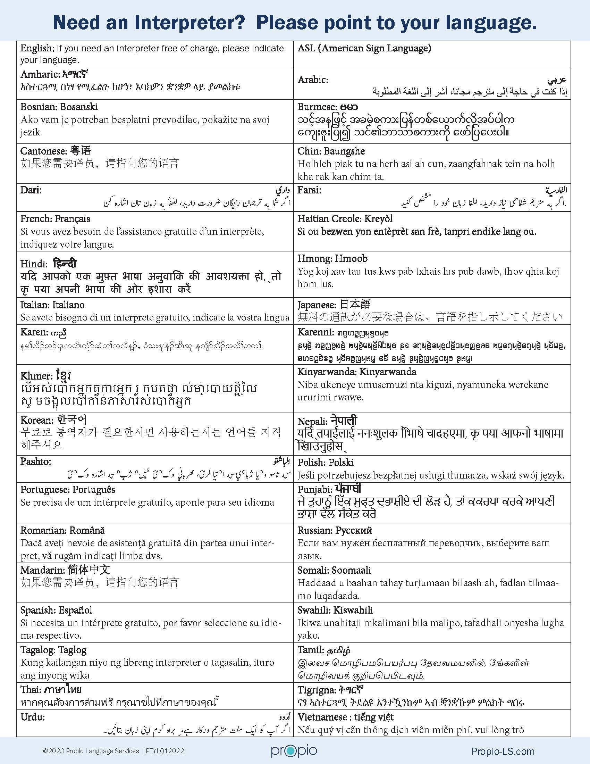
Propio has provided a table to help assist individuals who need an interpreter. This table allows an individual to indicate that they need an interpreter and shows which language they select. Below is the table they provided.

Interpreting Languages
There are over 300 remote interpreting languages available through Propio. To view the full list please go to: https://propio.com/language-codes/ .
The City of Bismarck is committed to providing nondiscriminatory service. No person shall, on the basis of a person's national origin, race, color, disability, sex, age, and/or income status, be excluded from participation or be subjected to discrimination or harassment by the City of Bismarck or any of its locations.
Contact Leanne Schmidt, Director of Human Resources and Title VI Coordinator for the City of Bismarck, at 701-355-1332 or lschmidt@bismarcknd.gov to request additional information on our nondiscrimination obligations or to file a complaint.

Title VI/ADA Complaint Form
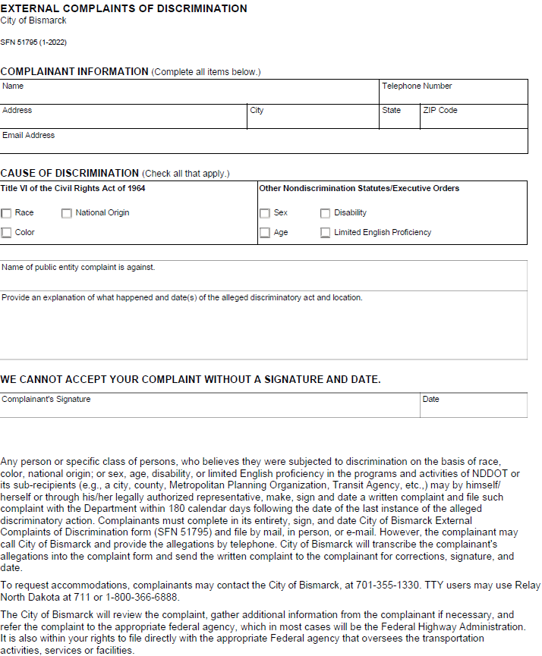
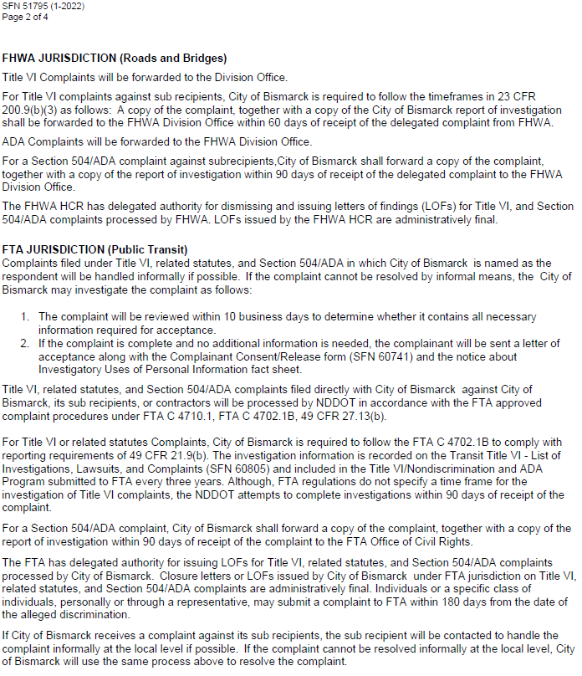

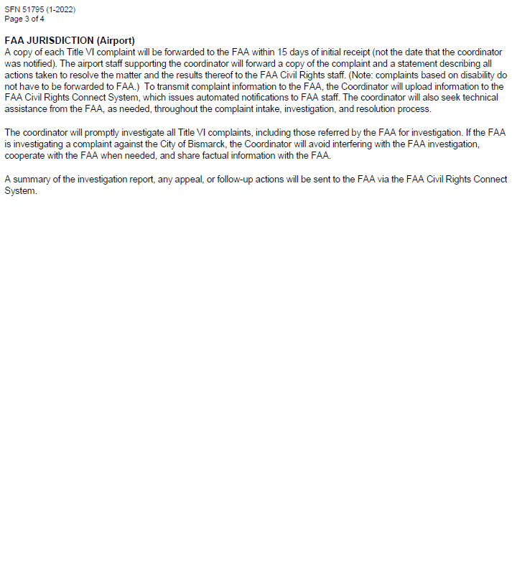

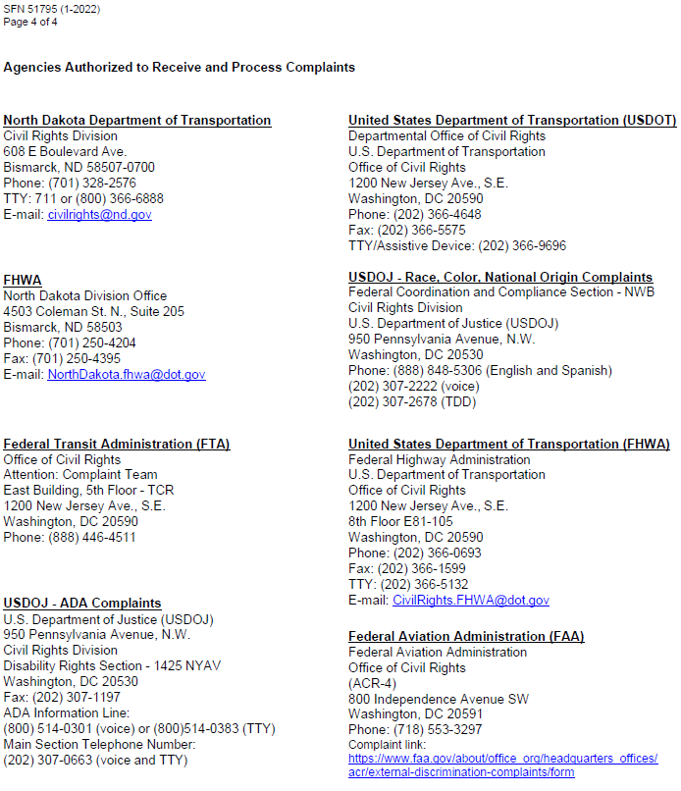

Title VI Complaint Log
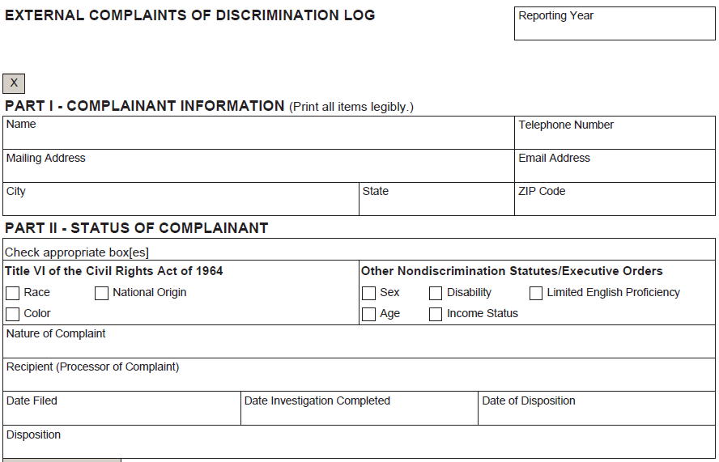

Title VI Recipient Checklist
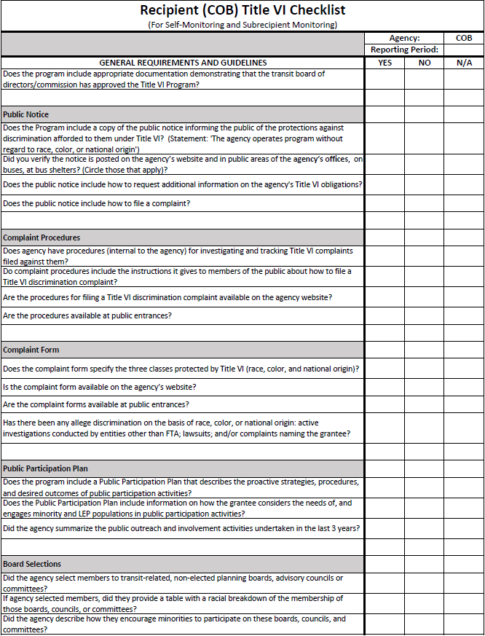
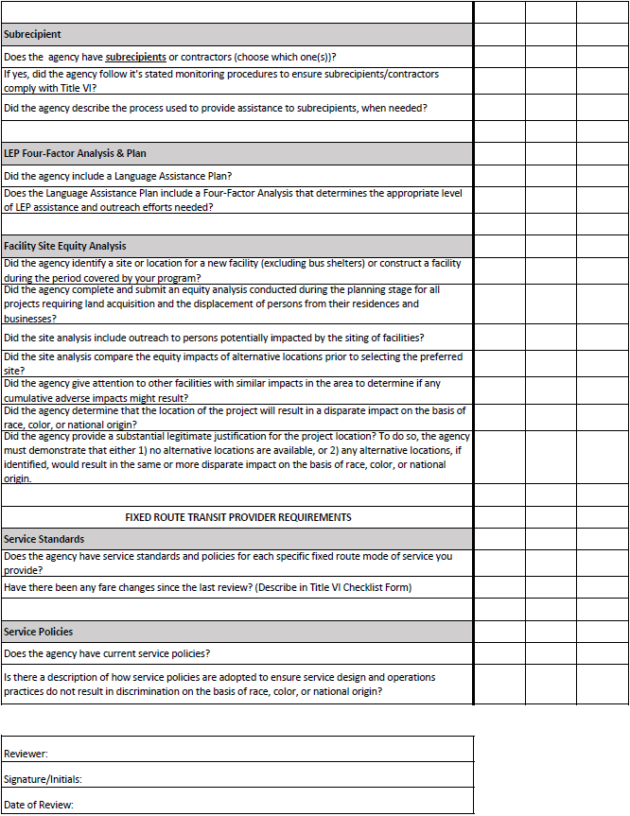

(Questions Posed to COB Title VI Program and LAP)

Evaluation Year:
Date of Evaluation:
Reviewer:

TVI1. Did the recipient prepare and submit a Title VI Program?

BASIC REQUIREMENT: A recipient is required to prepare and submit a Title VI Program based on the recipient’s transit-related characteristics.

COMPLIANCE CHECK:
- Did the recipient develop and submit a Title VI Program in TrAMS?
- If the recipient submitted a Title VI program and FTA has issued correspondence indicating required revisions, has the recipient made those revisions?

TVI2. Does the recipient provide meaningful access to LEP persons?
BASIC REQUIREMENT: A recipient must implement a language assistance plan (LAP) to address the needs of the population it serves.

COMPLIANCE CHECK:
- Does the LAP include the following?
  - Include the results of the Four Factor Analysis, with a description of the LEP population(s) served.
  - Describe how it provides language assistance services by language.
  - Describe how LEP persons are notified about the availability of language assistance.
  - Describe how it monitors, evaluates, and updates the LAP.
  - Describe how it trains employees to provide timely and reasonable language assistance.
- Has the recipient implemented its LAP? Demonstrate implementation via a review of the Four Factor Analysis (as outlined in its Title VI Program in Trams) and completion of the following table.

LAP Element | Description in Title VI Plan for Each Element
Languages identified in four factor analysis
Vital documents to be Translated
Language assistance training for staff
Periodic updating and monitoring of LAP

TVI3. Does the recipient notify the public of its rights under Title VI?

BASIC REQUIREMENT: A recipient must provide information regarding its Title VI obligations to the public and apprise members of the public of the protections against discrimination afforded to them by Title VI.

COMPLIANCE CHECK:
- Does the recipient disseminate the required Title VI Notice to the public as described in its Title VI Program?
- Is the Title VI Notice translated into languages identified in the recipient’s LAP?
- Does the Title VI Notice include all three of the required elements:
  - A statement that the agency operates programs without regard to race, color, or national origin.
  - A description of the procedures that members of the public should follow in order to request additional information on the recipient’s Title VI obligations.
  - A description of the procedures that members of the public shall follow in order to file a Title VI discrimination complaint against the recipient.

TVI4. Does the recipient implement complaint procedures as described in its Title VI Program?

BASIC REQUIREMENT: A recipient must make its procedures for filing a complaint available to the public, and investigate, and track Title VI complaints filed against it.

COMPLIANCE CHECK:
- Does the recipient use the complaint form(s) and instructions for filing complaints identified in its Title VI Program?
- Are the complaint form and instructions available on the recipient’s website and at other locations described in its Title VI Program?
- Are the complaint form and instructions translated into languages identified in the recipient’s LAP?
- Is the recipient processing complaints as described in its Title VI Program and its complaint instruction forms?

TVI5. Has the recipient implemented the public participation plan from its Title VI Program in its public participation activities?

BASIC REQUIREMENT: A recipient’s public participation plan shall offer early and continuous opportunities for the public, including minority and LEP populations, to be involved in the identification of social, economic, and environmental impacts of proposed transportation decisions.

COMPLIANCE CHECK:
- Have Title VI considerations been identified in the plan and integrated into the recipient’s public participation or outreach activities?

TVI6. Does the recipient monitor its subrecipients for compliance with Title VI requirements?

BASIC REQUIREMENT: A recipient is responsible for ensuring that its subrecipients comply with Title VI requirements.

COMPLIANCE CHECK:
- Has the recipient collected and reviewed subrecipient Title VI Program?
- How does the recipient monitor subrecipients to ensure that they are complying with Title VI requirements?
- Results of Subrecipient monitoring activities.
- Approval by the Bismarck City Commission of subrecipient monitoring results.
- Last date of Bismarck City Commission Approval of the Bis-Man Transit Title VI Program

ADDITIONAL COMPLIANCE QUESTIONS/ACTIONS FOR RECIPIENT:
- Has the recipient conducted the required equity analysis for any new transit facilities sited since the last Comprehensive (Triennial) Review
- Has the recipient evaluated fare and major service changes and monitored transit service?
- Does the recipient include the needs of minorities in planning activities; document that it passes Federal Transit Administration (FTA) funds through to subrecipients without regard to race, color, or national origin; and assure that minority populations are not being denied the benefits of or excluded from participation in FTA-funded programs?
- RECIPIENT SELF-MONITORING:
  - Last date of City of Bismarck Commission Approval for Recipient Title VI Program:
  - Results of recipient self-monitoring activities that have occurred since the last Recipient Title VI Review:
  - Communication with the City Administrator regarding Recipient Title VI Review and Title VI Program:
  - Last Approval from the Bismarck City Commission regarding Title VI self-monitoring results.
- APPLICTIONS:
  - Efforts within the review period to receive applications from agencies serving predominantly minority and low-income populations.
  - Record of accepted and rejected applications identifying applicants that are minority organizations or that provide assistance to minority or low-income communities for the current review period.
- MPO RELATED:
  - Documentation of how the metropolitan planning organization (MPO) identified the needs of minority communities in the transportation planning process.
  - Documentation of how MPO has included minority communities in the planning process that has occurred since the last Title VI Program submission.

Title VI Subrecipient Monitoring Checklist Form
(Questions Posed to Any Subrecipient Regarding Title VI Program)

Evaluation Year:
Date of Evaluation:
Reviewer:

TVI1. Did the subrecipient prepare and submit a Title VI Program?

BASIC REQUIREMENT: A subrecipient is required to prepare and submit a Title VI Program based on the recipient’s transit-related characteristics. The Title VI Plan should be provided to the recipient and DBE Liaison Officer upon approval of the Bis-Man Transit Board.

COMPLIANCE CHECK:
- Did the subrecipient develop and submit a Title VI Program to the Recipient and DBE Liaison Officer?

TVI2. Does the subrecipient provide meaningful access to LEP persons?

BASIC REQUIREMENT: A subrecipient must implement a language assistance plan (LAP) to address the needs of the population it serves.

COMPLIANCE CHECK:
- Does the LAP include the following?
  - Include the results of the Four Factor Analysis, with a description of the LEP population(s) served.
  - Describe how it provides language assistance services by language.
  - Describe how LEP persons are notified about the availability of language assistance.
  - Describe how it monitors, evaluates, and updates the LAP.
  - Describe how it trains employees to provide timely and reasonable language assistance.
- Has the subrecipient implemented its LAP? Demonstrate implementation via a review of the Four Factor Analysis (as outlined in its Title VI Program in Trams) and completion of the following table.

LAP Element | Description in Title VI Plan for Each Element
Languages identified in four factor analysis
Vital documents to be Translated
Language assistance training for staff
Periodic updating and monitoring of LAP

TVI3. Does the subrecipient notify the public of its rights under Title VI?
BASIC REQUIREMENT: A subrecipient must provide information regarding its Title VI obligations to the public and apprise members of the public of the protections against discrimination afforded to them by Title VI.

COMPLIANCE CHECK:
- Does the subrecipient disseminate the required Title VI Notice to the public as described in its Title VI Program?
- Is the Title VI Notice translated into languages identified in the recipient’s/subrecipient’s LAP?
- Does the subrecipient’s Title VI Notice include all three of the required elements:
  - A statement that the agency operates programs without regard to race, color, or national origin.
  - A description of the procedures that members of the public should follow in order to request additional information on the subrecipient’s Title VI obligations.
  - A description of the procedures that members of the public shall follow in order to file a Title VI discrimination complaint against the recipient.

TVI4. Does the subrecipient implement complaint procedures as described in its Title VI Program?

BASIC REQUIREMENT: A subrecipient must make its procedures for filing a complaint available to the public, and investigate, and track Title VI complaints filed against it.

COMPLIANCE CHECK:
- Does the subrecipient use the complaint form(s) and instructions for filing complaints identified in its Title VI Program?
- Are the complaint form and instructions available on the subrecipient’s website and at other locations described in its Title VI Program?
- Are the complaint form and instructions translated into languages identified in the recipient’s/subrecipient’s LAP?
- Is the subrecipient processing complaints as described in its Title VI Program and its complaint instruction forms?

TVI5. Has the subrecipient implemented the public participation plan from its Title VI Program in its public participation activities?

BASIC REQUIREMENT: A subrecipient’s public participation plan shall offer early and continuous opportunities for the public, including minority and LEP populations, to be involved in the identification of social, economic, and environmental impacts of proposed transportation decisions.

COMPLIANCE CHECK:
- Have Title VI considerations been identified in the plan and integrated into the subrecipient’s public participation or outreach activities?

TVI6. Does the subrecipient monitor its vendors/contractors for compliance with Title VI requirements?

BASIC REQUIREMENT: A subrecipient is responsible for ensuring that its vendors/contractors comply with Title VI requirements.

COMPLIANCE CHECK:
- Has the subrecipient collected and reviewed vendor/contractor Title VI Programs?
- How does the subrecipient monitored the vendors/contractors to ensure that they are complying with Title VI requirements?

For more information about website accessibility, please visit ADA.gov.
We will not subject any persons to discrimination based on race, color, national origin, age, sex, or creed. The term “protected communities” is used within this Title VI Plan to highlight the requirements of Title VI, 49 U.S.C. § 47123, the Age Discrimination Act of 1975, and, in some instances, includes low-income populations under Executive Order 12898.
“Affected communities” means any readily identifiable group potentially impacted by an airport project or operation, such as the community immediately surrounding a project or a community in the flight path.
Low-income data must be collected to assist in our compliance with Environmental Justice requirements (not Title VI requirements). For example, this data will be utilized in our Community Participation Plan (CPP) to help ensure the meaningful involvement of low-income communities in airport programs and activities.
Recommend using demographic groups from the U.S. Census.
In order to carry out an alternative with a discriminatory impact, the airport sponsor must demonstrate that there was a substantial legitimate justification for the decision. The sponsor must also show that alternatives with less discriminatory impacts were meaningfully considered and rejected for legitimate reasons.

