
Dear Citizen,
The Bismarck Police Department is proud of its employees. It is very rewarding to everyone in our department to know that people appreciate their hard work and dedication. If you would like to commend the actions of an employee or employees of the Police Department, we would like to hear about your experience so that we can pass your comments on to the appropriate people who were involved.
If you have any questions regarding this form or the Bismarck Police Department commendation process, please contact the Bismarck Police Department’s Administrative Services Lieutenant at 701-223-1212 or via email at bismarckpd@bismarcknd.gov.
Forms may be sent to the Bismarck Police Department Administrative Services Lieutenant via e-mail, US Mail or delivered to the Bismarck Police Department, 700 S. 9th Street, Bismarck, ND 58504.
Respectfully,
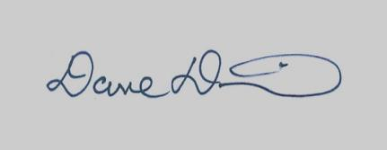
DAVE DRAOVITCH
Chief of Police

Bismarck Police Department

Citizen Commendation Form

Name |  |  |  | Today’s Date | Case or Traffic Accident Number (If Known)
Address |  |  |  |  | City |  | State |  |  |  | Zip Code
Cell Phone # |  | Home Phone # |  | Work Phone # |  |  |  | Best Time to Call
Nature of Commendation |  |  |  | Name of Officer(s) Involved (If Known)
Location of Incident |  |  |  | Date and Time of Incident
Details of the Incident (Please use the back of this page or a supplemental page if necessary)

If you have any questions regarding this form or the Bismarck Police Department commendation/complaint process, please contact the Bismarck Police Department’s Administrative Services Lieutenant at 701-223-1212 or bismarckpd@bismarcknd.gov
Forms may be sent to the Administrative Services Lieutenant via e-mail, US Mail or delivered to the Bismarck Police Department, 700 S. 9th Street, Bismarck, ND 58504
Signed |  |  |  |  |  |  |  |  |  | Date
PD Use  Only | Received By |  | Date Received |  |  | Number of Pages  Attached |  |  | Date Received by  Admin Services

